

IT342-[Section]
System Integration and Architecture

System Design Document (SDD)

Project Title: [Insert Project Name]
Prepared By: [Lastname, Firstname Middlename]

Version: [e.g. 1.0]
Date: [Current Date]
Status: [Draft/Final]

REVISION HISTORY TABLE
Version | Date | Author | Changes Made | Status
0.1 | [Date] | [Your Name] | Initial draft | Draft
0.2 | [Date] | [Your Name] | Added API specifications | Review
0.3 | [Date] | [Your Name] | Updated database design | Review
0.4 | [Date] | [Your Name] | Added UI/UX designs | Review
0.5 | [Date] | [Your Name] | Incorporated feedback | Revised
0.6 | [Date] | [Your Name] | Final review and corrections | Final
1 | [Date] | [Your Name] | Baseline version for development | Approved

TABLE OF CONTENTS
Contents
EXECUTIVE SUMMARY 4
1.0 INTRODUCTION 5
2.0 FUNCTIONAL REQUIREMENTS SPECIFICATION 5
3.0 NON-FUNCTIONAL REQUIREMENTS 8
4.0 SYSTEM ARCHITECTURE 9
5.0 API CONTRACT & COMMUNICATION 10
Authentication Endpoints 11
User Registration 11
User Login 11
6.0 DATABASE DESIGN 13
7.0 UI/UX DESIGN 14
8.0 PLAN 17

EXECUTIVE SUMMARY
1.1 Project Overview
Marketplace MVP is a simplified e-commerce platform that enables users to browse products, manage shopping carts, and complete purchases. The system includes a Spring Boot backend API, React web application, and Android mobile app, all integrated to provide a seamless shopping experience across platforms.
1.2 Objectives
- Develop a fully functional e-commerce MVP with authentication, product catalog, shopping cart, and checkout
- Implement a three-tier architecture using Spring Boot (backend), React (web), and Android (mobile)
- Create RESTful APIs for communication between all system components
- Design a responsive user interface that works consistently across web and mobile platforms
- Deploy all system components to production-ready environments
1.3 Scope
Included Features:
- User registration and authentication (email/password)
- Product listing with search functionality
- Shopping cart management (add, remove, update quantities)
- Checkout process with shipping information collection
- Order placement with confirmation
- Admin panel for product management
- Responsive web interface
- Native Android mobile application
- PostgreSQL database with relational schema
Excluded Features:
- Real payment gateway integration
- Product reviews and ratings system
- Inventory management automation
- Email notification system
- Social media login integration
- Push notifications
- Advanced analytics dashboard

1.0 INTRODUCTION
1.1 Purpose
This document serves as the comprehensive design specification for the Marketplace MVP system. It provides detailed requirements, architectural decisions, API contracts, database design, and implementation roadmap to guide development and ensure all components integrate seamlessly.

2.0 FUNCTIONAL REQUIREMENTS SPECIFICATION
2.1 Project Overview
Project Name: Marketplace MVP
Domain: E-commerce/Retail
Primary Users:
- Customers
- Administrators
Problem Statement: Users need a simple, fast way to browse and purchase products without the complexity of large e-commerce platforms.
Solution: A minimalist marketplace focusing on core shopping functionality with consistent experience across web and mobile.
2.2 Core User Journeys
Journey 1: First-time Customer Purchase
- User visits web application
- Clicks "Sign Up" and creates account
- Browses product listing
- Clicks product to view details
- Adds product to cart
- Views cart and proceeds to checkout
- Enters shipping information
- Places order and receives confirmation
Journey 2: Returning Customer Purchase
- User logs in with existing credentials
- Searches for specific product
- Adds multiple products to cart
- Updates cart quantities
- Completes checkout using saved information
- Receives order confirmation
Journey 3: Administrator Product Management
- Admin logs in with admin credentials
- Navigates to product management section
- Adds new product with details
- Edits existing product information
- Views list of all orders
- Manages product inventory
2.3 Feature List (MoSCoW)
MUST HAVE
- User authentication (register, login, logout)
- Product catalog (list, detail, search)
- Shopping cart (add, remove, update, view)
- Checkout process (shipping, order placement)
- Admin panel (product CRUD, order view)
SHOULD HAVE
- Product categories and filtering
- Order history for users
- Basic input validation feedback
- Responsive design for all screen sizes
COULD HAVE
- Product wishlist
- Basic sales dashboard
- Order status tracking
WON'T HAVE
- Real payment processing
- Email notifications
- Social login
- Advanced analytics
- Multi-language support
2.4 Detailed Feature Specifications
Feature: User Authentication
- Screens: Registration, Login, Forgot Password
- Fields: Email, Password, Confirm Password
- Validation: Email format, password strength, uniqueness
- API Endpoints: POST /auth/register, POST /auth/login, POST /auth/logout
- Security: JWT tokens, password hashing with bcrypt
Feature: Product Catalog
- Screens: Product Listing, Product Detail
- Display: Grid layout, product images, names, prices
- Search: By product name
- API Endpoints: GET /products, GET /products/{id}, GET /products/search
- Admin Functions: POST /products, PUT /products/{id}, DELETE /products/{id}
Feature: Shopping Cart
- Screens: Cart View
- Functions: Add product, remove product, update quantity
- Persistence: Database storage per user
- API Endpoints: GET /cart, POST /cart/items, PUT /cart/items/{id}, DELETE /cart/items/{id}
Feature: Checkout Process
- Screens: Checkout Form, Order Confirmation
- Data Collected: Shipping address (name, address, city, zip)
- Process: Validate input, create order, clear cart
- API Endpoints: POST /orders, GET /orders/{id}
Feature: Admin Panel
- Screens: Product Management, Order List
- Functions: Add/edit/delete products, view orders
- Access Control: Admin role required
- API Endpoints: Admin-prefixed endpoints with role validation
2.5 Acceptance Criteria
AC-1: Successful User Registration
- Given I am a new user
- When I enter valid email and strong password
- And confirm password matches
- And click "Create Account"
- Then my account should be created
- And I should be automatically logged in
- And redirected to the homepage
AC-2: Product Purchase Flow
- Given I am logged in as a customer
- When I add a product to my cart
- And proceed to checkout
- And enter valid shipping information
- And place the order
- Then I should see order confirmation
- And my cart should be empty
- And the order should appear in admin panel

AC-3: Admin Product Management
- Given I am logged in as an administrator
- When I add a new product with valid details
- And save the product
- Then the product should appear in customer product listing
- And be available for purchase

3.0 NON-FUNCTIONAL REQUIREMENTS
3.1 Performance Requirements
- API response time: ≤ 2 seconds for 95% of requests
- Web page load time: ≤ 3 seconds on broadband
- Mobile app cold start: ≤ 3 seconds
- Support 100 concurrent users
- Database queries complete within 500ms
3.2 Security Requirements
- HTTPS for all communications
- JWT token authentication
- Password hashing with bcrypt (salt rounds = 12)
- SQL injection prevention
- XSS protection
- Rate limiting: 100 requests/minute per IP
- Admin endpoints require role verification
3.3 Compatibility Requirements
- Web Browsers: Chrome, Firefox, Safari, Edge (latest 2 versions)
- Android: API Level 24+ (Android 7.0+)
- Screen Sizes: Mobile (360px+), Tablet (768px+), Desktop (1024px+)
- Operating Systems: Windows 10+, macOS 10.15+, Linux Ubuntu 20.04+
3.4 Usability Requirements
- Complete first purchase within 5 minutes for new users
- WCAG 2.1 Level AA compliance for web
- Consistent navigation across all pages
- Clear error messages with recovery options
- Touch targets minimum 44x44px on mobile
- Keyboard navigation support

4.0 SYSTEM ARCHITECTURE
4.1 Component Diagram
Note: This should be a component diagram
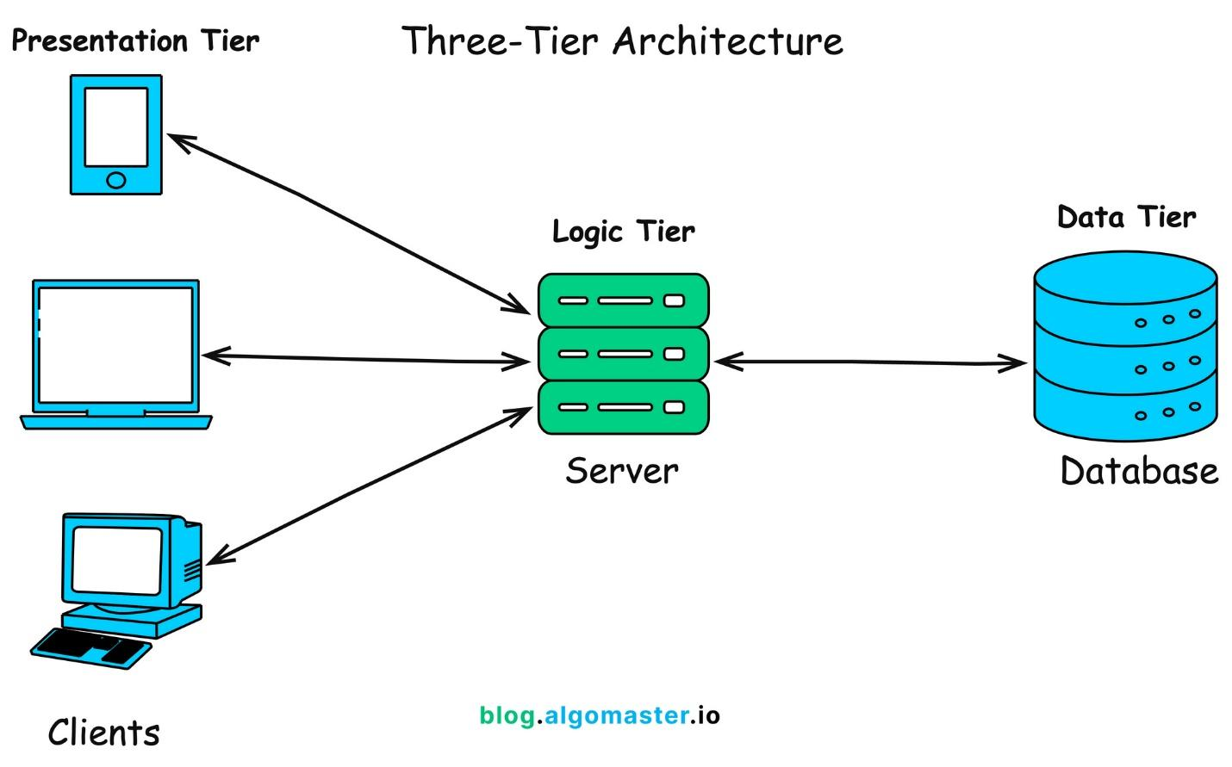
Technology Stack:
- Backend: Java 17, Spring Boot 3.x, Spring Security, Spring Data JPA
- Database: PostgreSQL 14+
- Web Frontend: React 18, TypeScript, Tailwind CSS, Axios
- Mobile: Kotlin, Jetpack Compose, Retrofit, Room
- Build Tools: Maven (Backend), npm/yarn (Web), Gradle (Android)
- Deployment: Railway/Heroku (Backend), Vercel/Netlify (Web), APK (Mobile)

5.0 API CONTRACT & COMMUNICATION
5.1 API Standards
Base URL | https://[server_hostname]:[port]/api/v1
Format | JSON for all requests/responses
Authentication | Bearer token (JWT) in Authorization header
Response Structure | {  "success": boolean,  "data": object|null,  "error": {  "code": string,  "message": string,  "details": object|null  },  "timestamp": string  }

5.2 Endpoint Specifications

Authentication Endpoints

User Registration
Description | User Registration
API URL | /auth/register
HTTP Request Method | POST
Format | JSON for all requests/responses
Authentication | None
Request Payload | {  “email”: <email>,  “password”: <password>,  “firstname”: <firstname>,  “lastname”: <lastname>,  }
Response Structure | {  "success": boolean,  "data": {  user {  “email”: <email>,  “firstname”: <firstname>,  “lastname”: <lastname>,  },  “accessToken”: <token>,  “refreshToken”: <token>,  },  "error": {  "code": string,  "message": string,  "details": object|null  },  "timestamp": string  }

User Login
Description | User Login
API URL | /auth/login
HTTP Method | POST
Format | JSON for all requests/responses
Authentication | None
Request Payload | {  “email”: <email>,  “password”: <password>,  }
Response Structure | {  "success": boolean,  "data": {  “user”: {  “email”: <email>,  “firstname”: <firstname>,  “lastname”: <lastname>,  “role”: <role>,  },  “accessToken”: <token>,  “refreshToken”: <token>,  },  "error": {  "code": string,  "message": string,  "details": object|null  },  "timestamp": string  }

5.3 Error Handling
HTTP Status Codes
- 200 OK - Successful request
- 201 Created - Resource created
- 400 Bad Request - Invalid input
- 401 Unauthorized - Authentication required/failed
- 403 Forbidden - Insufficient permissions
- 404 Not Found - Resource doesn't exist
- 409 Conflict - Duplicate resource
- 500 Internal Server Error - Server error
Error Code Examples

Example 1 | json  {  "success": false,  "data": null,  "error": {  "code": "AUTH-001",  "message": "Invalid credentials",  "details": "Email or password is incorrect"  },  "timestamp": "2024-01-28T10:30:00Z"  }
Example 2 | {  "success": false,  "data": null,  "error": {  "code": "VALID-001",  "message": "Validation failed",  "details": {  "email": "Email is required",  "password": "Must be at least 8 characters"  }  },  "timestamp": "2024-01-28T10:30:00Z"  }

Common Error Codes
- AUTH-001: Invalid credentials
- AUTH-002: Token expired
- AUTH-003: Insufficient permissions
- VALID-001: Validation failed
- DB-001: Resource not found
- DB-002: Duplicate entry
- BUSINESS-001: Insufficient stock
- SYSTEM-001: Internal server error

6.0 DATABASE DESIGN
6.1 Entity Relationship Diagram
Note: This should be an ERD (Database Schema)
Detailed Relationships:
- One-to-One: User ↔ Cart (Each user has exactly one cart)
- One-to-Many: User → Orders (User can have multiple orders)
- One-to-Many: Cart → CartItems (Cart contains multiple items)
- One-to-Many: Order → OrderItems (Order contains multiple items)
- Many-to-One: CartItems → Product (Items reference products)
- Many-to-One: OrderItems → Product (Items reference products)
Key Tables:
- users - User accounts and authentication
- products - Product catalog information
- carts - Shopping cart per user
- cart_items - Items in shopping cart
- orders - Customer orders
- order_items - Items in each order
- refresh_tokens - JWT refresh tokens
Table Structure Summary:
- users: id, email, password_hash, full_name, role, created_at
- products: id, name, description, price, stock, image_url, category
- carts: id, user_id, created_at
- cart_items: id, cart_id, product_id, quantity
- orders: id, order_number, user_id, total, status, shipping_address
- order_items: id, order_id, product_id, product_name, quantity, price

7.0 UI/UX DESIGN
7.1 Web Application Wireframes
Note: This should be wireframes from Figma
Homepage (Product Listing)
Header: [Logo] [Search Bar] [Cart Icon] [User Menu]
Content: Product Grid (3 columns desktop)
Each Product Card: Image, Name, Price, "Add to Cart" button
Footer: Links, Copyright

Product Detail Page
Back Button
Product Image (large)
Product Name and Price
Description
Quantity Selector (1-10)
"Add to Cart" and "Buy Now" buttons
Product Specifications

Shopping Cart Page
Cart Title
List of Cart Items (Image, Name, Quantity, Price, Remove)
Order Summary: Subtotal, Shipping, Tax, Total
"Continue Shopping" and "Proceed to Checkout" buttons

Checkout Page
Shipping Address Form
Order Review (Items, Prices, Totals)
"Place Order" button
Terms and Conditions note

Admin Dashboard
Sidebar Navigation: Dashboard, Products, Orders, Users
Product Management: Add New button, Product list with Edit/Delete
Order Management: Order list with status filters

7.2 Mobile Application Wireframes
Note: This should be wireframes from Figma
Bottom Navigation
[🏠 Home] [🔍 Search] [🛒 Cart] [👤 Profile]
Home Screen
Search Bar
Product Grid (2 columns)
Swipe gestures for quick actions
Pull to refresh

Product Detail Screen
Back arrow
Product image (swipeable gallery)
Product info
Quantity selector
"Add to Cart" fixed bottom button

Cart Screen
Edit mode for quantity updates
Swipe to remove items
Order summary sticky bottom
Checkout button

Checkout Flow
Step indicator: Cart → Shipping → Payment → Confirm
Address form (auto-complete)
Order summary
Place order button
Mobile-Specific Features:
- Touch-optimized buttons (min 44x44px)
- Gesture support (swipe, pull-to-refresh)
- Offline caching for product images
- Bottom navigation for main actions
- Simplified forms for mobile input
Design System:
- Colors: Primary (#2563EB), Secondary (#7C3AED), Success (#10B981), Error (#EF4444)
- Typography: Inter font family, responsive sizing
- Spacing: 8px grid system
- Components: Consistent buttons, inputs, cards, modals
- Responsive: Mobile-first approach, breakpoints at 640px, 768px, 1024px

8.0 PLAN
8.1 Project Timeline
Phase 1: Planning & Design (Week 1-2)
Week 1: Requirements & Architecture
Day 1-2: Project setup and documentation
Day 3-4: Complete FRS and NFR
Day 5-7: System architecture design

Week 2: Detailed Design
Day 1-2: API specification
Day 3-4: Database design
Day 5-6: UI/UX wireframes
Day 7: Implementation plan finalization

Phase 2: Backend Development (Week 3-4)
Week 3: Foundation
Day 1: Spring Boot setup with dependencies
Day 2: Database configuration and entities
Day 3: JWT authentication implementation
Day 4: User management endpoints
Day 5: Product CRUD operations

Week 4: Core Features
Day 1: Cart functionality
Day 2: Order management
Day 3: Search and filtering
Day 4: Error handling and validation
Day 5: API documentation and testing

Phase 3: Web Application (Week 5-6)
Week 5: Frontend Foundation
Day 1: React setup with TypeScript
Day 2: Authentication pages (login, register)
Day 3: Product listing page
Day 4: Product detail page
Day 5: Shopping cart implementation

Week 6: Complete Web Features
Day 1: Checkout flow
Day 2: Order history and confirmation
Day 3: Admin dashboard
Day 4: Responsive design polish
Day 5: API integration and testing

Phase 4: Mobile Application (Week 7-8)
Week 7: Android Foundation
Day 1: Android Studio setup and project structure
Day 2: Authentication screens
Day 3: Product browsing
Day 4: Shopping cart
Day 5: API service layer

Week 8: Complete Mobile App
Day 1: Checkout flow
Day 2: Order management
Day 3: UI polish and animations
Day 4: Testing on emulator/device
Day 5: APK generation and documentation

Phase 5: Integration & Deployment (Week 9-10)
Week 9: Integration Testing
Day 1: End-to-end testing across platforms
Day 2: Bug fixes and optimization
Day 3: Security review
Day 4: Performance testing
Day 5: Documentation updates

Week 10: Deployment
Day 1: Backend deployment (Railway/Heroku)
Day 2: Web app deployment (Vercel/Netlify)
Day 3: Mobile APK distribution
Day 4: Final testing
Day 5: Project submission
Milestones:
- M1 (End Week 2): All design documents complete
- M2 (End Week 4): Backend API fully functional
- M3 (End Week 6): Web application complete
- M4 (End Week 8): Mobile application complete
- M5 (End Week 10): Full system deployed and integrated
Critical Path:
- Authentication system (Week 3)
- Product catalog API (Week 3-4)
- Shopping cart functionality (Week 4)
- Checkout process (Week 6)
- Cross-platform testing (Week 9)
Risk Mitigation:
- Start with simplest working version of each feature
- Test integration points early and often
- Keep backup of working versions
- Focus on core functionality before enhancements

